February 13, 2020

Statewide CT Young Adult Homelessness Report:

Release Notes

What are these Reports?
The new Statewide, Regional Youth Reports and the Youth Client Lists provides and an ongoing census of unaccompanied young adults age, 18-24 , experiencing homelessness in CT as well as an assessment of the response to young adult homelessness. These reports include the following:
- State Monthly Youth Reports
  - Table 1 - CAN Appointments
  - Table 2 - Population , Inflow & Outflow
  - Table 3 - Most Recent location of Youth with Open Cases
  - Table 4 - Performance metrics
- Monthly Regional Client List
  - Housed , Exited and Aged Out Client in the last 90 days
  - Currently Open Cases

Which users are impacted?
All user role entering and viewing individual youth records are impacted. This includes users from the entire Coordinated Access system; Youth Navigators, System Administrators, the CANs, DOH, ES, SO, SHP, SSVF, TLP, CCEH and all other users .

How does this help?
These reports will assist staff, YETI and CAN leaders, statewide agencies, and other stakeholders understand the regional and statewide progress towards ending young adult homelessness. As part of the YHDP project led by the Department of Housing, CCEH, and the regional programs and YETI leads, these reports will provide easier access in viewing a fuller scope of young adult homelessness. In particular, these reports provide current data on system performance measures, the status and trajectories of individual youth, and the regional breakdowns for each CAN/YETI. With these reports, users will be able to assess more quickly the progress and trends towards making individual youth homelessness rare, brief and non-recurring.

When will I see this change in HMIS?
The reports will be rolled out on February 14, 2020.
Summary of Statewide Reports:
- CAN Appointments shows total number of individual youth who were scheduled for CAN appointments .
  - Attended - Clients who attended scheduled appointment
  - No Show - Clients who did not attend scheduled appointment
  - Unprocessed - Clients whose status remains “referred from 211”
  - Call to Appt Time - Average # of days from calling 211 to scheduled appointment date
  - # diverted - Total # of clients diverted before and at CAN appointment from 211
  - % diverted – Proportion of clients diverted

- Population, Inflow & Outflow
  - Tracks how the population of youth experiencing homelessness is trending over a six month period. The population includes youth enrolled in most programs: Youth Navigator, Shelter Outreach, Emergency Shelters, Transitional Housing, Diversion/Rapid Exit, Homeless Prevention, Services Only, Rapid Rehousing with no move-in date and Permanent Supportive Housing with no move-in date. It also includes youth who are on the By-Name-List (BNL) but are not currently enrolled in any other program
  - Entrances - includes a count of all youth who entered the population, as defined above, that month
  - Exits – includes a count of all youth who became inactive on the BNL or exited one of the programs included in the population, as defined above. Exits are broken into four categories: permanent exits, temporary exits, other exits and exits to an institutional setting
  - Aged Out but not Housed – includes youth who have turned 25 without exiting homelessness and are currently only enrolled in an emergency shelter or shelter outreach program.
- Most Recent Location - This shows current location of all individual youth with open cases
  - Population - accounts for all youth with open enrollment during month in view
  - ES - # of individual youth age 18- 24 enrolled in emergency shelters
  - TH - # of individual youth age 18- 24 enrolled in transitional living programs
  - Not in ES/ TH - # of individual youth age 18- 24 enrolled in other programs but ES and TH

- Performance Metrics
Tracks how swiftly youth are exiting homelessness, the percentage of permanent exits, and the
net inflow. These metrics are tracked over both a monthly and 90 day period and are measured
in two ways: including transitional housing programs and not including transitional housing
programs.
- Percentage of Permanent Exits within 45 days: calculates the youth who were permanently housed, and the percent who were permanently housed within 45 days
- Percentage of Permanent Exits within 46 to 90 days: the percent of youth who were permanently housed within 46 to 90 days
- Percentage of Permanent Exits over 90 days: the percent of youth who it took over 90 days to become permanently housed
- Average Episode Length: calculated using average (mean) number of days from most recent CAN appointment (or program enrollment in absence of CAN appointment date) to date housed
- Percentage Permanent Exits: proportion of permanent exits compared to total exits, which includes the de-duplicated number of exits to temporary, permanent, other or institutional locations.
- Net Inflow: calculates the difference between de-duplicated entrances and exits (whether outflow is equal to or greater than inflow). If outflow is greater, then net inflow will be negative.
Samples of the Monthly Statewide/ Regional and Client List reports are shown below:
Statewide/Regional Youth Reports are accessible to all user roles in HMIS using reporting icon which brings you to Compliance Reports (Org) panel. In addition, CCEH will be sharing the statewide version of the Youth Reports with stakeholders on the 15th of each month.
The Youth Client List is accessible to all user roles in HMIS using the Compliance Reports (Org) Panel. For assistance in accessing this list, please contact Nutmeg for technical support.
How to access reports:
Youth Client List
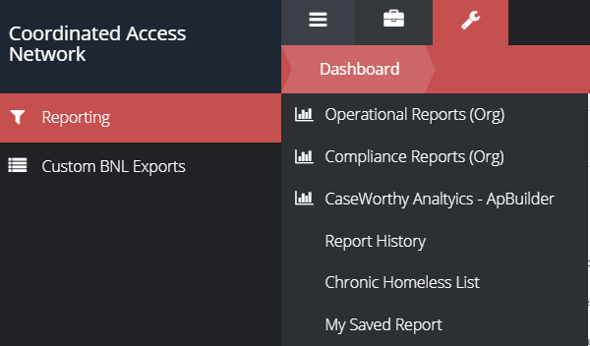
brings you to the view below
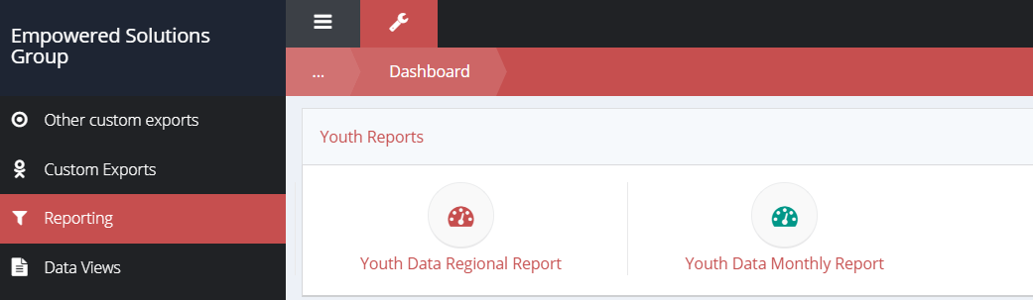

Click on the Youth Data Regional Report to bring you to this view
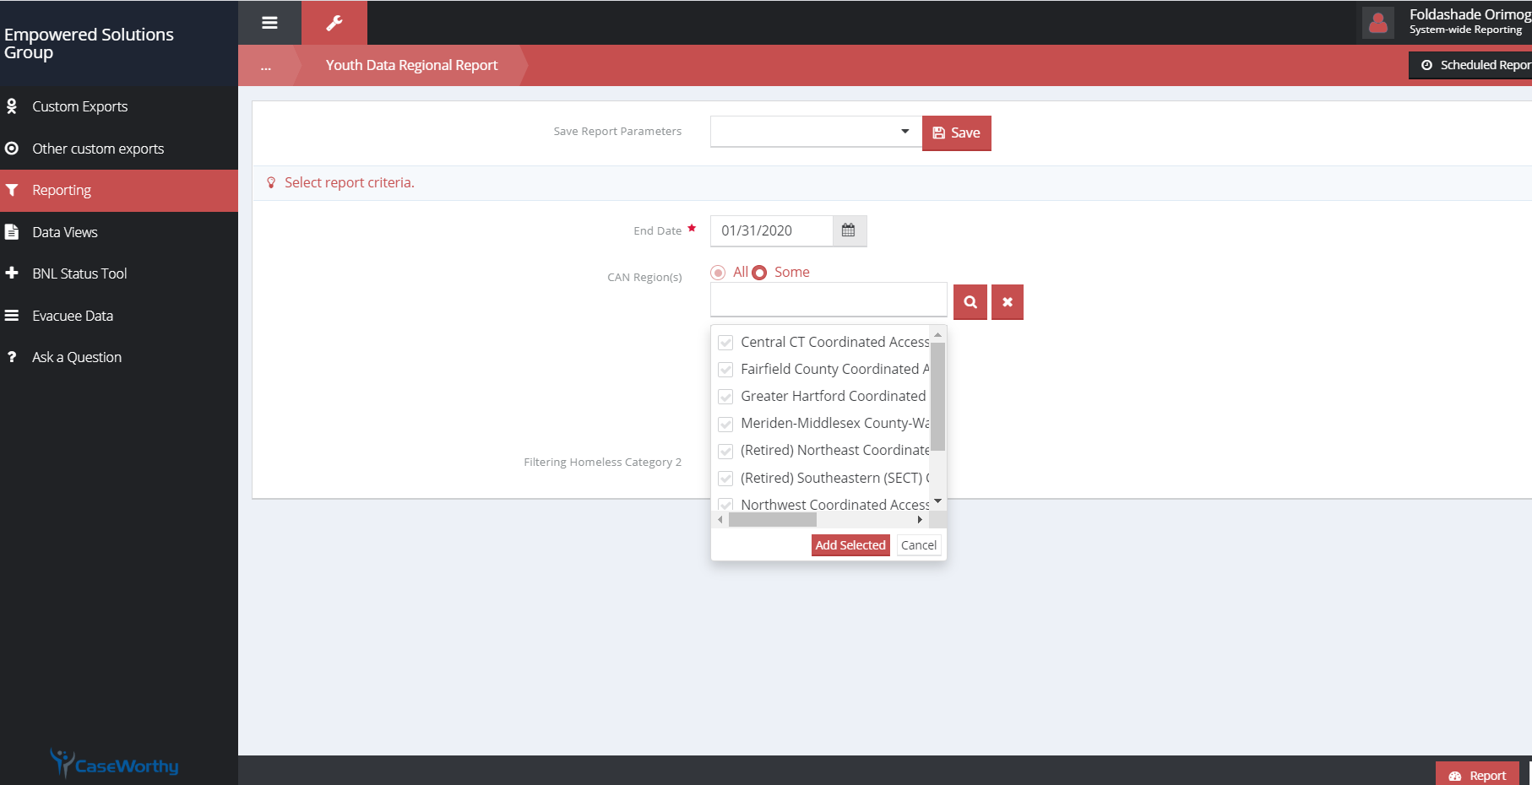

Input date, CAN region(s). You can also the check box to filter out Category 2 clients and click report at the lower right of the report page.
Youth Client List will appear on screen:
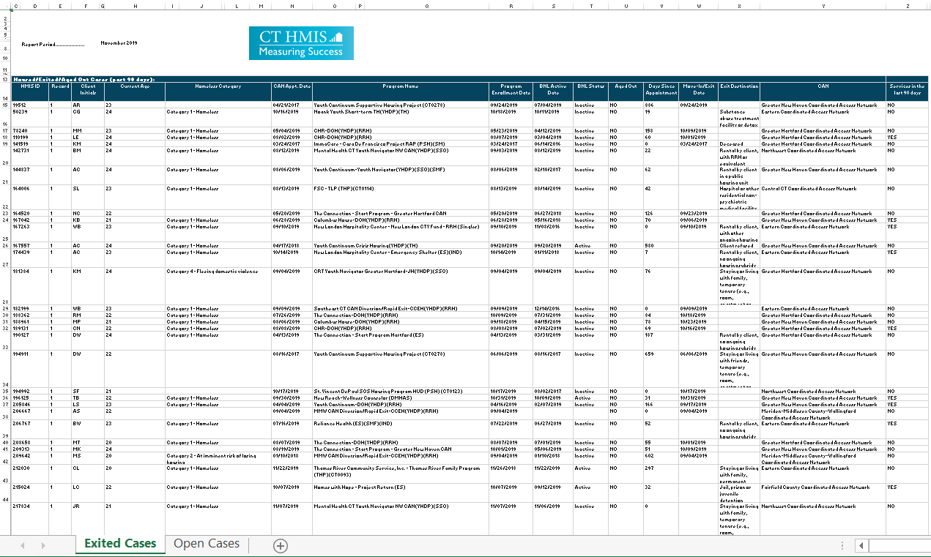

Exporting report: click on the floppy disk icon to expand the drop down menu which offers various exporting options.
Excel option is however recommended for easy data manipulation.
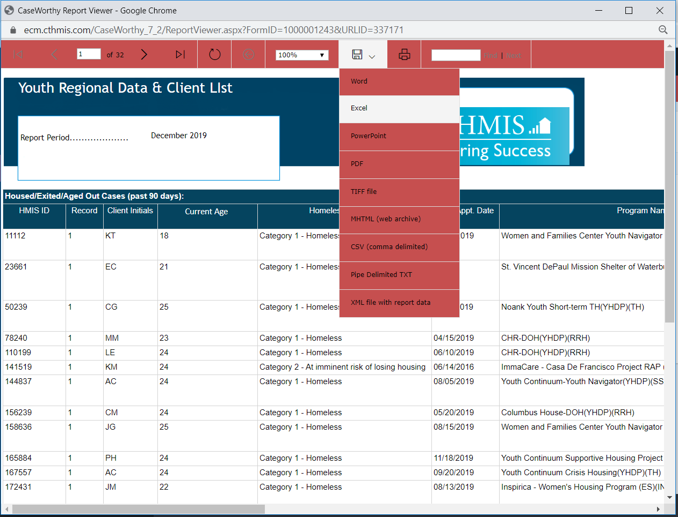

A sample of Exported Report: 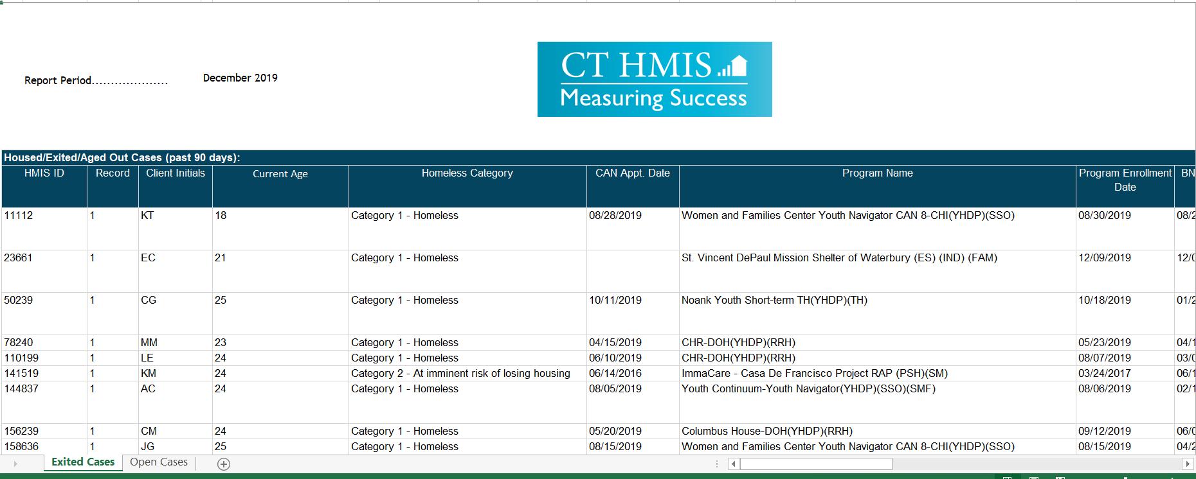

Statewide/ Regional Youth Data

brings you to the view below

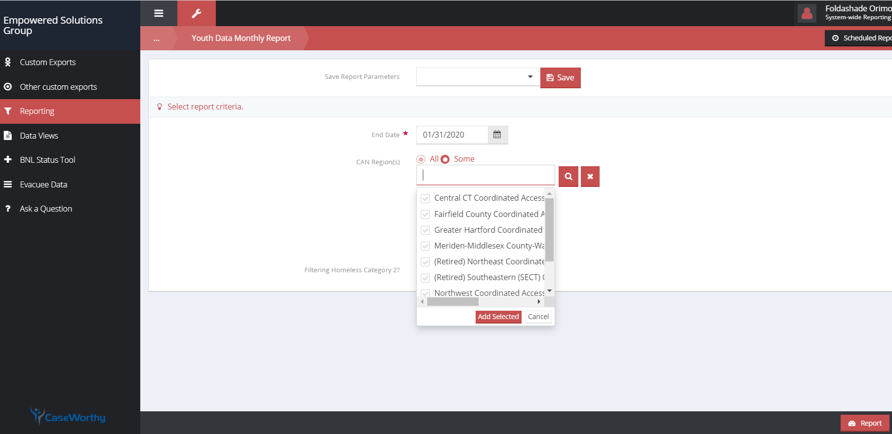

Input date, CAN region(s). You can also the check box to filter out Category 2 clients and click report on the lower right of the report page.
Statewide report will appear on screen:

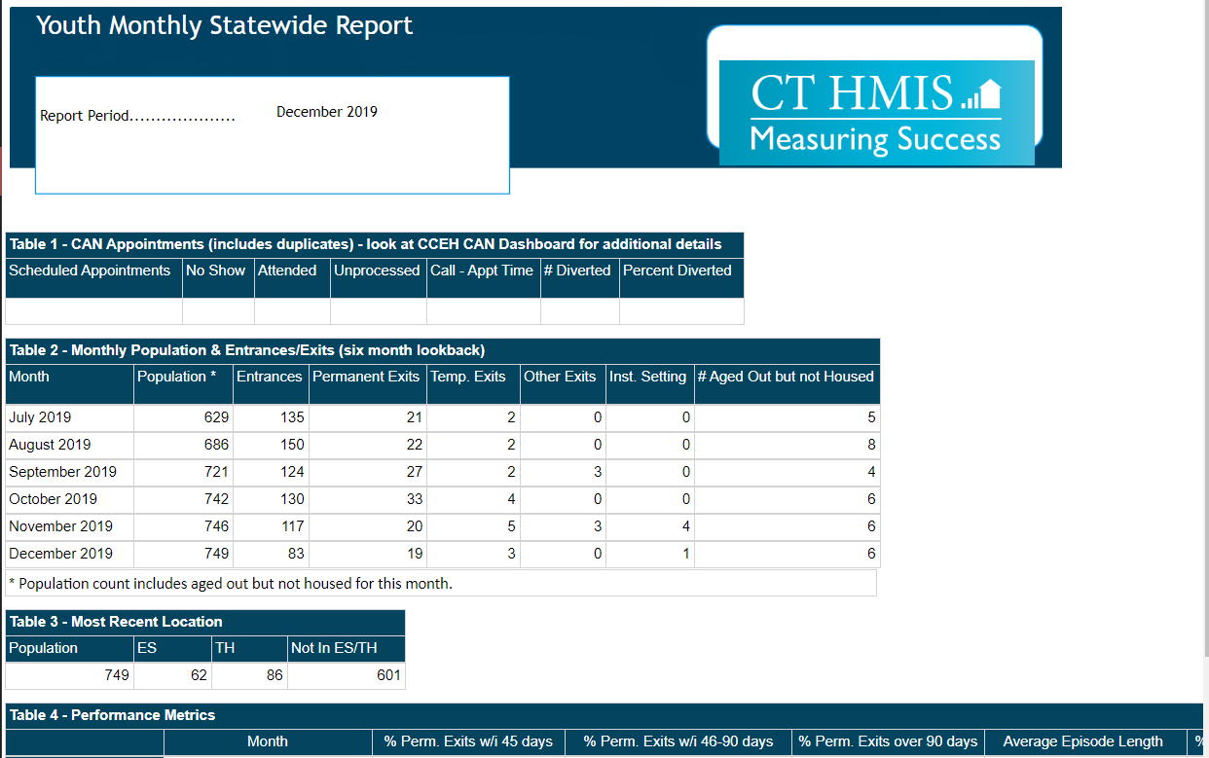
Exporting report: click on the floppy disk icon to expand the drop down menu which offers various exporting options.
Excel option is however recommended for easy data manipulation of back-up data for tables 2 through to 4 .
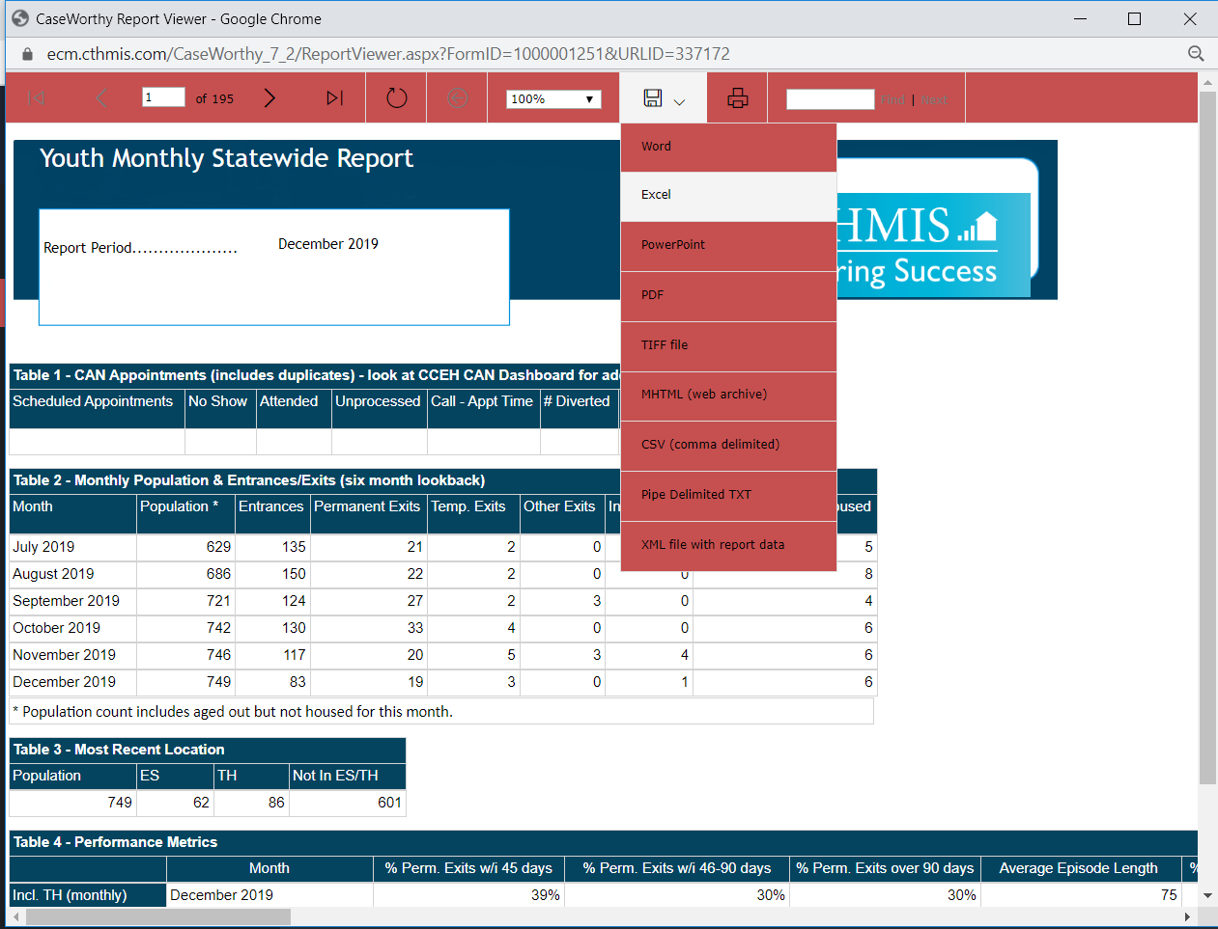
A sample of Exported Report:
