Still needs info on the bed drop alert

RRH People Count Data to Back Fill Bed Count Fields:
For HMIS participating RRH programs, users can first confirm their people count data. Once the user has confirmed the people count information the PIT App will auto update the bed count information to match the total persons counted by household type.
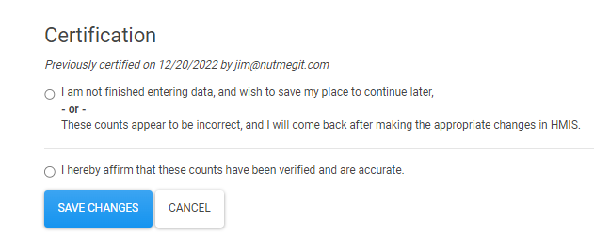

Households with at least one adult and one child:
The PIT App will use the household count to populate the number of units and it will use the total person count to populate the number of beds.

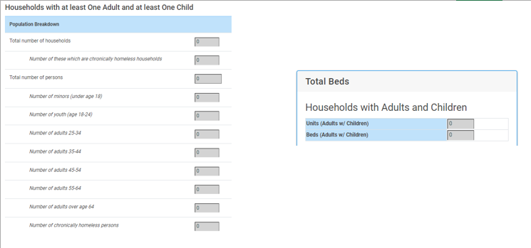

Households with Adults only:
The PIT App will use the total person count to populate the ‘undesignated’ field for the bed count. If this number should be split by gender, then the user can manually make those changes on the bed count side.
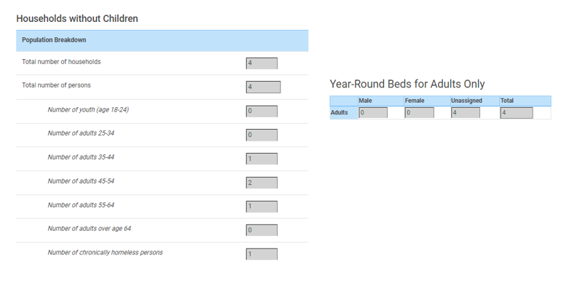

Bed count fields that will not auto update are the Beds Dedicated to Sub-Populations. The user will need to provide the bed counts for these fields.

