New Gender and Race Categories:
Gender:
- For HMIS participating programs, these fields will up date with what has been entered in HMIS. Your only job will be to make sure they are showing correctly.
- For Non-HMIS participating programs, you will need to manually enter your numbers.
- The top section represents the primary responses. The counts for these options should be equal to the total number of people served.
- For example, if the total person count is 5, then the total number of genders entered in the top section should equal 5.
- If you have anyone who identifies as ‘More Than One Gender’ then you will enter all their gender identifications in the lower section.
- For example, if 4 people identify as ‘Woman’ then you would put a ‘4’ in that box in the top section. If 1 person identifies as ‘More Than One Gender’ then you would put a ‘1’ in that box so the top section = 5.
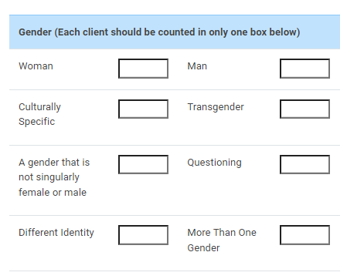
- The lower section is where you would enter a ‘1’ for each gender they identify as. This section must be at least 2 times the number entered in the ‘More Than One Gender’ box.
- For example, if 1 person identifies more than one gender then there should be at least 2 genders selected in the lower section.
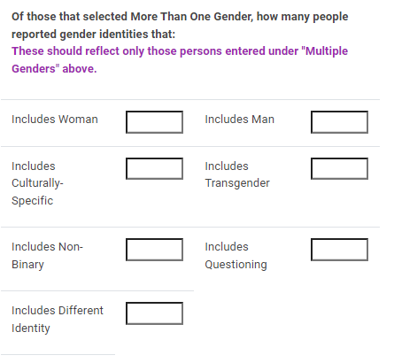
Race/Ethnicity:
- Race and Ethnicity has been combined. This means someone can identify either as just Hispanic/Latino or a combination including Hispanic/Latino or not include Hispanic Latino.
- The total number of Race/Ethnicity should equal the total number of persons served. This includes those counted in the Multiples section.
- If someone identifies as more than one Race/Ethnicity then enter those numbers in either of the ‘Multiple’ options provided.
