How to complete the non-hmis data collection form for DOH outreach and warming center programs:
Link to smart sheet data collection form:
https://app.smartsheet.com/b/form/1dc9aa47499345dd8f9adcd87cb862bc

- Take a minute to read the summary
- Complete each data entry field. If you don’t know the person’s HMIS ID that is fine, you can leave that blank.
- We will need the full name, DOB and SSN however in order to remove duplicates on the night of the PIT count.
- You will complete a separate data entry form for each person encountered on the night of PIT including all family members, those under 18 and over 18.
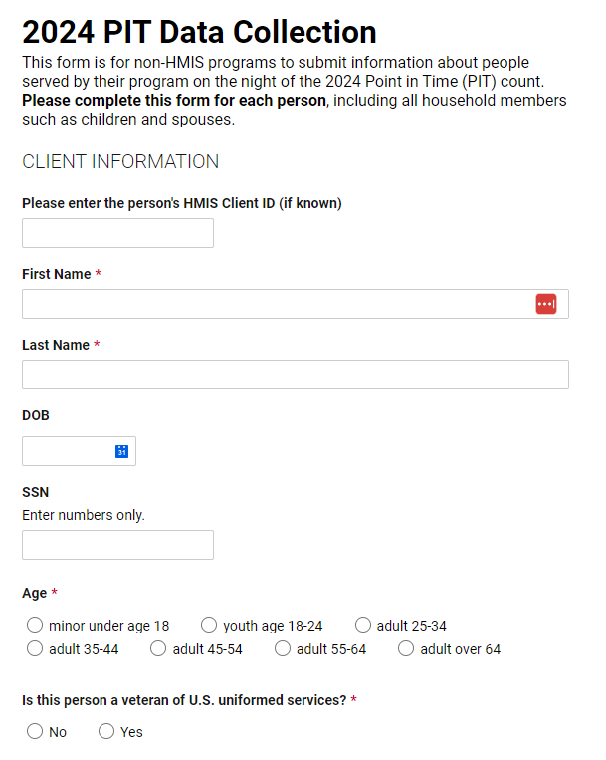
- For each person encountered provide the demographic information below.
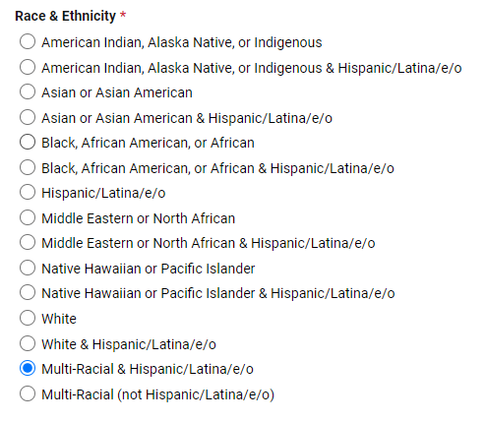
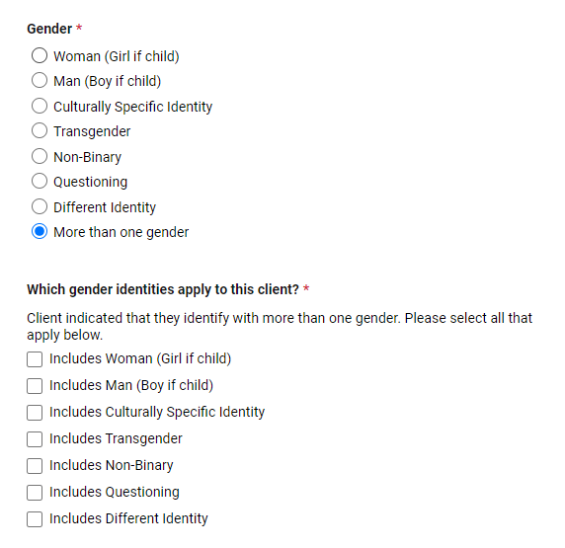
- For Household type – a household can be a person presenting alone, or a household of more than one person.
  - Household with adults and children means that the person is part of a household where there is at least one person over 18 and one person under 18. – examples:
    - 30-year-old parent with an 11-year-old and an 18-year-old
    - 32-year-old parent; 29-year-old parent and 17-year-old child
    - 55-year-old grandparent; 24-year-old adult child with a 5-year-old child/grandchild
  - Household with adults only means everyone in the household is 18 or over. This can be a single person or multiple adults presenting together – examples:
    - 45-year-old parent and their 19-year-old adult child
    - Two cohabitating adults
    - Single adult 18 or older
  - Single adult household can be used as an option when there is just one person 18 or over. You could also use option ‘b’ to represent this household type.
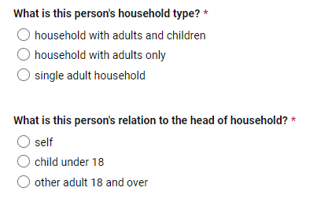
- The program information and user information is below. There are only a select list of programs who will be using this form. If you do not see your program in this list please contact the nutmeg help desk at: help@nutmegit.com
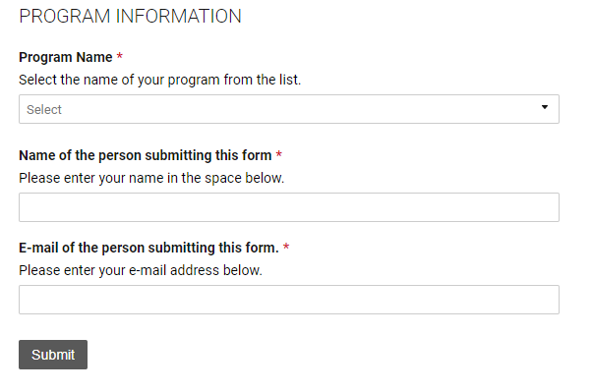

- After hitting submit you are done with this first step. Nutmeg will be importing the data into the PIT App. Once we have completed that step, we will contact all users who provided their email contact on the form.
- Your next task will be to confirm your data in the PIT App. You will log into the PIT App and click on the ‘unsheltered count’ button
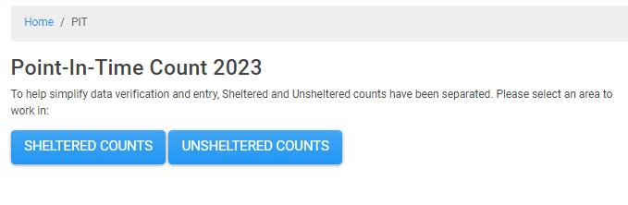
- You will then locate your program and click on the pencil icon to edit
- For each table make sure to check the data for accuracy and enter ‘0’ into any blank fields.
- Check the Additional Homeless Population data and provide the counts for each category if known.
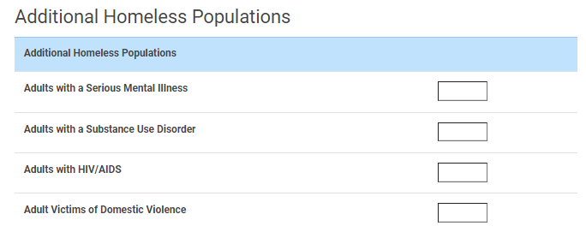
- After confirming the data click on the certification and save
