All Non-HMIS PH/PSH programs will only need to provide a Total Household count and Total Person count. This includes any VASH, EHV or any other programs that are program type PSH, PH, PIH or OH with the ‘(PIT Only)’ label.
For each table provide those counts. If you don’t have numbers for households and/or persons on any of the tables the just enter a ‘0’ in the household field and total person field. All other fields can be left blank.
Example table with counts:
If you have counts on this table then you also have to provide counts in the Veteran Households with Adults and Children table as well.
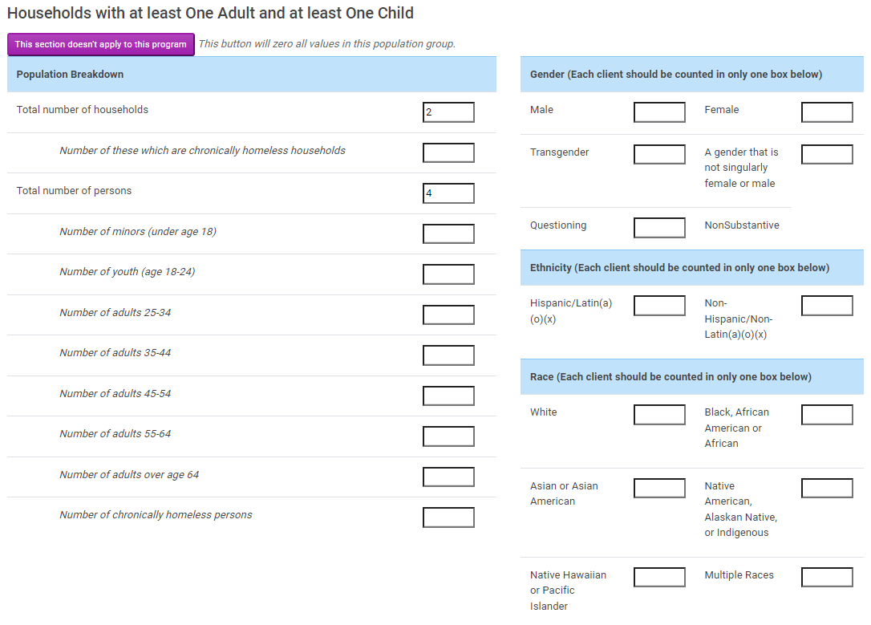
Example table without counts:
If you did have counts on this table you would also need to provide the counts in the Veteran Household with Adults only below.
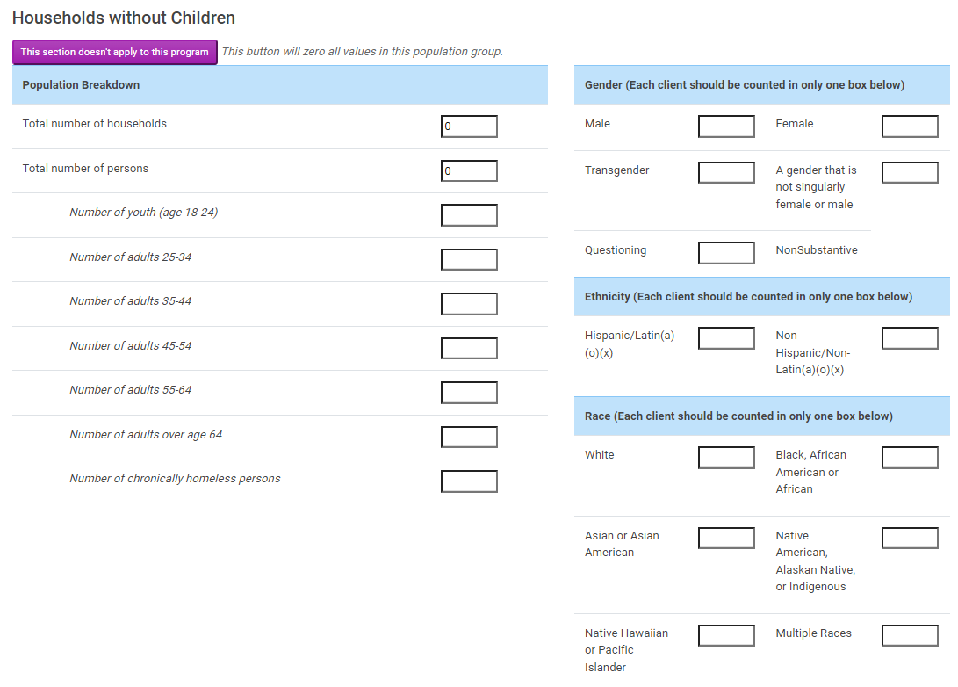

Example veteran specific table with data that relates to the primary table Households with Adults and Children above. If you didn’t any counts in the Households with Adults and Children table, then this table would have ‘0’ entered for households, total person and total veterans.
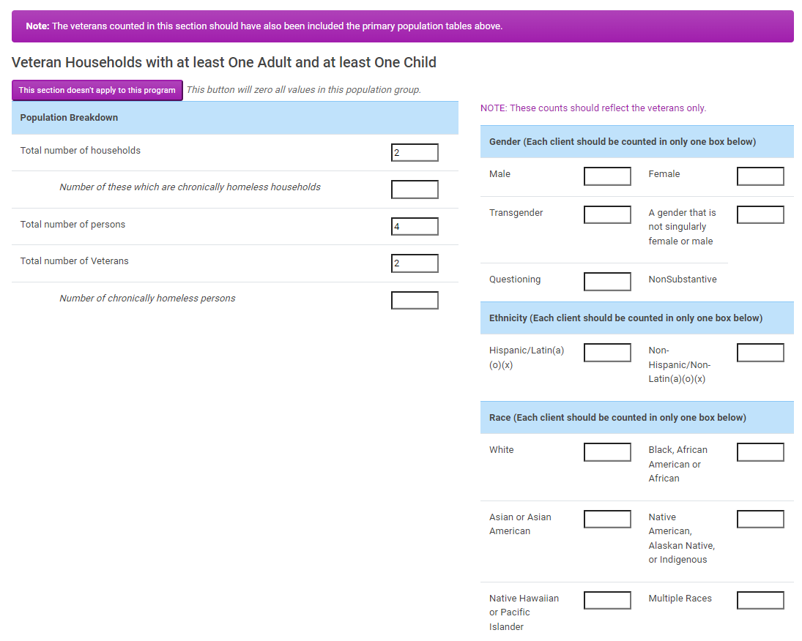

Example of veteran specific table with data that relates to the Households with only Adults table above:
If you had counts in the Households with Adults only table then you would need to also provide them here and identify the veteran count
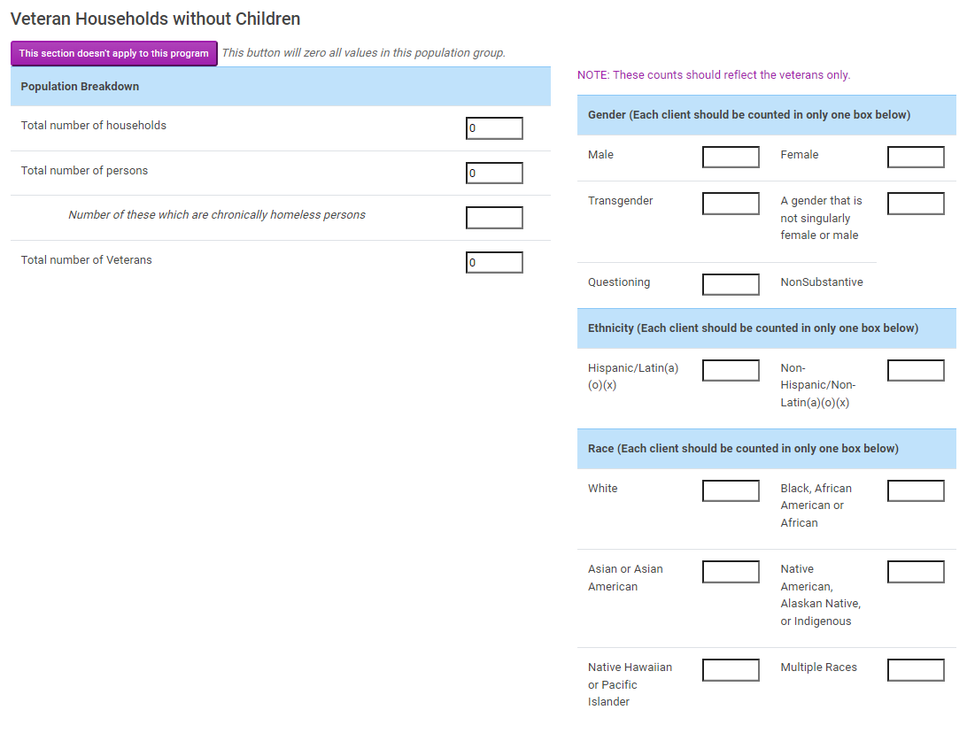

Example of the summary table:
Check your summary data. If you are over or under utilized then provide the necessary information and click confirm and save
