Total Person Count Validation:
- To evaluate the list of HMIS ID’s that are being pulled into the PIT Database, scroll down to the Summary Table and click on the ‘Reported Client IDs’ button
- This will give you list of ID’s that the PIT Database is finding that meet the PIT qualifications for the program type.
  - ES – these ID’s have an open enrollment and a shelter check-in dated for the night of the PIT Count 1/25/2022
  - PSH/RRH – these ID’s have an open enrollment and the head of household has a move in date dated on or before the PIT Count 1/25/2022
  - Street Outreach – these ID’s have an open enrollment and the head of household and all adult members have a current living situation assessment date the night of the PIT count 1/25/2022 and the living situation selected is a homeless setting i.e. ‘Place not meant for habitation’.
  - Transitional Housing – these ID’s have an open enrollment. This is the only qualification.
  - ES Hotel/Motel – these ID’s have an open enrollment and the Head of Household has Motel/Hotel Voucher service dated for the night of the PIT count
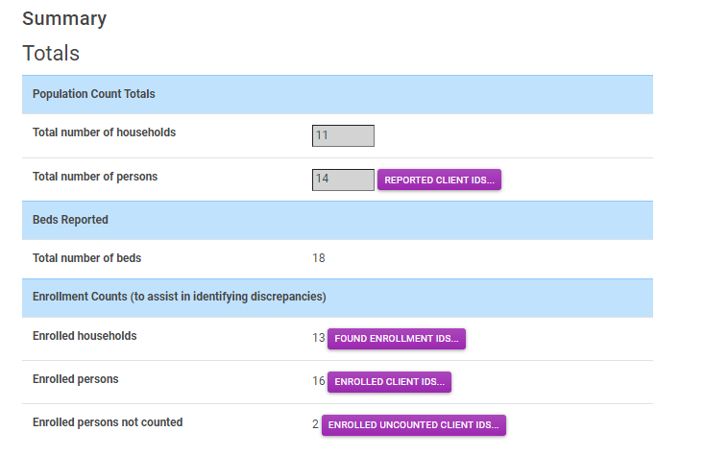
- There are 4 tools available to help identify if there are issues with either households or clients either counted or not counted in the PIT App.
- If you click on any of the buttons you will see a listing of the client ID’s. For example, if you click on the ‘reported client ID’s button it will show you the client id’s being counted as valid for the night of PIT
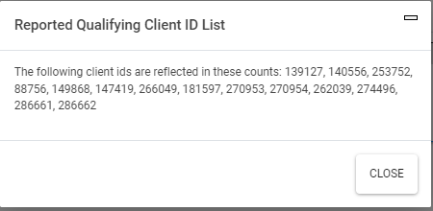
- On the night of PIT you may notice that the total number of client ID’s counted is less than the total number of ‘enrolled persons’
  - Note in the example below total number of person counted = 14 but the total number of enrolled persons = 16
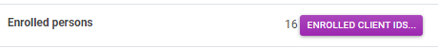
  - This is an indication that 2 clients were not counted as being eligible on the night of PIT. This may or may not be correct. To see who these clients are you can click on the ‘enrolled persons not counted’ button
  - This will show you the client ID’s for those client who are enrolled in the program but are being excluded from PIT. The reason for exclusion from PIT will depend on the program type, the enrollment status or some other more complex issue with the enrollment. You can review the qualifications information from step 2 above

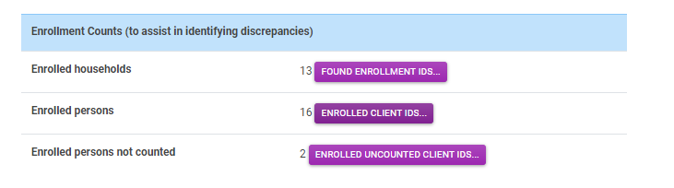

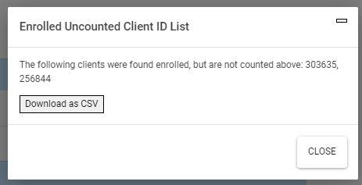
  - There is also a ‘download as CSV’ button. This button will create an excel export so if you have a large list of client ID’s that are excluded it will make it easier for you to manage.

  - If you are not able to determine why the records are not being counted then feel free to contact our help desk for assistance. help@nutmegit.com

