New for 2024-2025:
For PSH programs, we need to gain a grasp of how many beds that contribute to the underutilized bed count are due to beds being in ‘reserved’ status. Meaning, the bed may empty on the night of the PIT count but there is a Household that is slated for that bed or unit who are not yet occupying the bed/unit. If the number of persons counted on the night of PIT is less than the number of beds counted then you will need to provide an explanation, as was done last year. This year, you will also need to provide a count of reserved beds in those units that are reserved for multi-person households and/or the number of beds that are reserved for single person households.

In the example below you can see that there are 25 beds and only 18 people counted giving an occupancy rate of 72%.

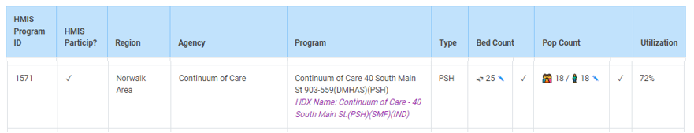

Click on the pencil icon in the Pop Count block and then scroll down to the end of the page to see the summary data. Note the total number of people and beds and the new beds fields in the ‘Underutilized’ section.

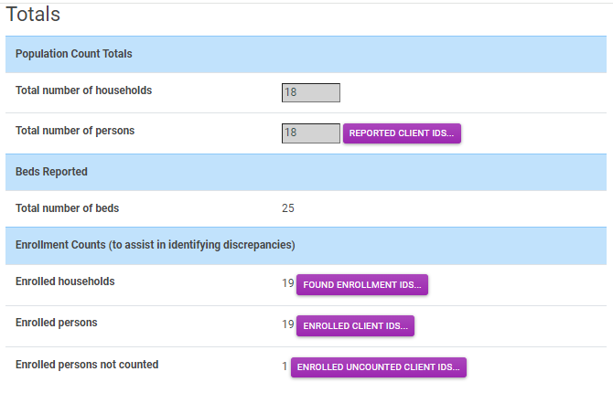

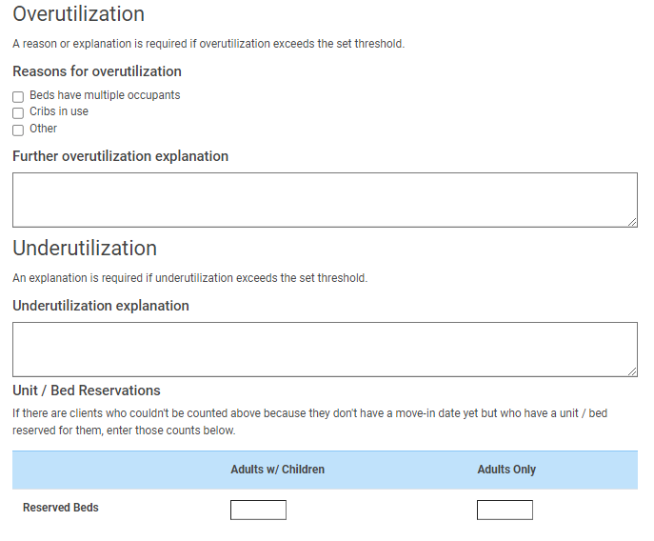
Example 1 Household with Adults and Children:
On the night of PIT your program has a count of 20 people and a count of 23 total beds. Those 3 empty beds are part of a family unit. You have a family identified for that unit but on the night of PIT that family is still in the emergency shelter because their lease does not begin until February 1, 2025. In the reserved bed section for Households with Adults and Children you will enter a ‘3’ in the beds box and a ‘0’ in the beds for Adults only box.

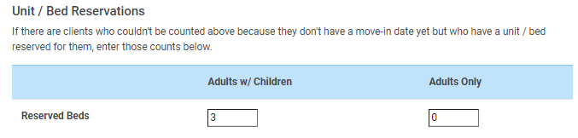

Example 2 Households with Adults Only:
On the night of PIT your program has a count of 50 people and a count of 75 total beds. Those 25 beds are all for individuals. You have 20 individuals identified for 20 of those beds on the night of PIT but those individuals are still in the emergency shelter because their leases don’t begin until February 2025. In the reserved bed section for Households with Adults only you will enter ‘20’ and in the Households with Adults and Children you will enter ‘0’ for beds.

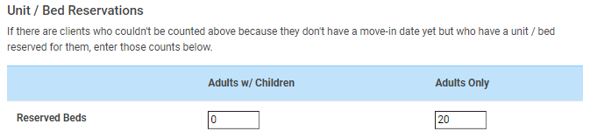

Once you have provide the reserved unit and bed information you can confirm and save. If you do not have any reserved units or beds just enter zeros in the fields.

Note: You could also have a scenario where you have reserved beds for both Households with children and Households with Adults only. In this case just enter the number in corresponding fields

