Contents

Primary Table 1: Households with at least One Adult and at Least One Child 2

Primary Table 2: Households without Children 2

Primary Table 3: Households with Parenting Children 3

Primary Table 4: Households with only Unaccompanied Children 4

Subpopulation 1: Veteran Households At least One Adult and at least One Child 4

Subpopulation 2: Veteran Households without Children 5

Subpopulation 3: Parenting Youth Households 5

Subpopulation 4: Unaccompanied Youth Households 6

Summary Totals 7

Utilization Tables 7

Universal Rules:

* Keep in mind that if the household is counted as Chronically Homeless, then all persons are counted as chronic homeless.
* The demographic categories of all **4 Primary Tables** should add up to the total number of persons. So, if there are 10 person the gender should add up to 10, ethnicity should add up to 10 and race should add up to 10.
* The Household count in any table can never be greater than the total person count.

# Primary Table 1: Households with at least One Adult and at Least One Child

The rules for this table are that the household must have at least one person under 18 and at least one person over 18.

You would not include a household where there is a parent and adult child who is over 18. For example, a 45-year-old parent and a 19-year-old adult child would not qualify for this table. They would go on the Households without children table.

* Examples of who would go on this table:
  + 30-year-old Parent and 17-year-old child
  + 40-year-old Parent, 18-year-old child and 10-year-old child
  + **19-year-old Parent and 3-year-old child --- Parenting Youth Example**
  + 60-year-old grandparent, 30-year-old parent and 11-year-old child
  + Cohabitating Parents, 19 and 25 with their 2-year-old child

Make sure to take note of any households where there are **unaccompanied parenting youth households** b/c you will need to count them separately in the Subpopulation table for Youth Households.

* An example of an unaccompanied parenting youth household would be:
  + 19-year-old parent and 2-year-old child where no one else in the household is over 24.
  + 20-year-old parent, 24-year-old parent and a 3-year-old child

# Primary Table 2: Households without Children

The rules for this table are that there are no members under the of 18. All members are 18 and over.

This is where you would count a household with a parent who has an adult child living with them. For example, a 40-year-old parent and a 19-year-old child would be counted here.

* Other examples would be:
  + Any one 18 years of age an older presenting alone
  + Cohabitating 19-year-old and a 25-year-old
  + Cohabitating 30-year-old and 35-year-old

Make sure to take note of any **unaccompanied youth households** b/c you will need to count them separately in the Subpopulation table for Youth Households.

* An example of an unaccompanied youth household:
  + 19-year-old presenting alone
  + Cohabiting 18-year-old and 24-year-old

# Primary Table 3: Households with Parenting Children

The rules for this table are that there is a parent or parents who are under 18 with a child. No one in the household can be over the age of 18. ***These tables should be blank for the majority of programs unless you provide services to Runaway Homeless Youth (RHY).***

* Examples of a Parenting child household are:
  + 17-year-old parent with a 2-year-old
  + Cohabitating 17-year-old and 16-year-old with a 1-year-old child

# 

# Primary Table 4: Households with only Unaccompanied Children

The rules for this table are that no one in the household can be over the age of 18 and no one in the household is a parent. ***These tables should be blank for the majority of programs unless you provide services to Runaway Homeless Youth (RHY).***

* Examples of an Unaccompanied Child household are:
  + 17-year-old presenting alone
  + Cohabitating 17-year-old and 16 year old

The remaining tables below are sub-population tables. These tables collect the data on veterans and unaccompanied youth or children who are part of the populations counted above. Example, if you counted 2 households with at least one adult and one child above and one of those households was a veteran household then you would provide the information for that veteran household below. These tables are not ‘in addition to’ your overall population. These tables are ‘of those counted above, how many are…’

# Subpopulation 1: Veteran Households At least One Adult and at least One Child

The rules for this table are to provide the data for any household counted in Primary table 1, Households with at least one adult and one child, where there is a veteran in the household.

* Examples of veteran households with at least one adult and one child:
  + 35-year-old parent who is a veteran with a 10-year-old child
  + 30-year-old co-habiting parents where one parent is a veteran, and they have a 9- and 12-year-old
  + 65-year-old grandparent, 40-year-old parent who is a veteran and a 16-year-old child

Once you have determined who your veteran households with children are, you will provide the numbers below. For demographics, you only need to provide the numbers for the veteran.

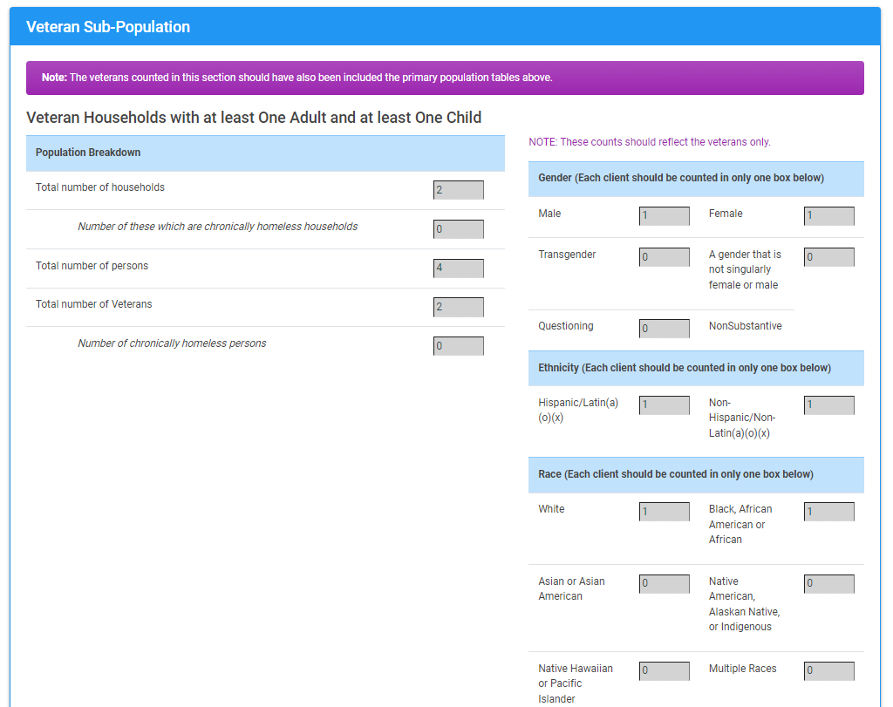

# Subpopulation 2: Veteran Households without Children

The rules for this table are to provide the data for any household counted in Primary table 2, Households without children, where there is a veteran in the household and there is no one under the age of 18 in the household.

* Examples of veteran households without children:
  + 40-year-old veteran with an 18-year adult child
  + Cohabitating 40-year-old and 38-year-old where the 40-year-old is a veteran
  + Unaccompanied 25-year-old who is a veteran

Once you have determined who your veteran households without children are, you will provide the numbers below. For demographics, you only need to provide the numbers for the veteran.

# Subpopulation 3: Parenting Youth Households

The rules for this table are to provide the data for any household counted in Primary table 1 (Households with at least one adult and one child) and Primary Table 3 (Households with Parenting Children). If you provided data in Primary Table 3, it will auto-populate for you. You will, however, have to manually enter the data for any parenting youth households from Table 1.

The definition of a parenting youth household:

* The parent is between the ages of 18-24
* The child or children presents with them in the program
* No one in the household is over the age of 24.

Example of a parenting youth household:

* 19-year-old Parent and 3-year-old child
* Cohabitating 20-year-old and 24-year-old parents with a 3-year-old child

Non-Parenting Youth Example: 40-year-old grandparent; 18-year-old parent with a 2-year-old child. This household would not count b/c there is someone over the age of 24 in the household.

The demographics for this table is for the parents only. Totals for each demographic category should add up to the total number of parents. If you provided counts that are greater than the total number of parents, you will get an error.

# Subpopulation 4: Unaccompanied Youth Households

The rules for this table are to provide the data for any household counted in Primary table 2 (Households without children) and Primary Table 4 (Households with Unaccompanied Children). If you provided data in Primary Table 4, it will auto-populate for you. You will, however, have to manually enter the data for any unaccompanied youth households from Table 2.

The definition of an unaccompanied youth household:

* The individual is between the ages of 18-24
* No one in the household is over the age of 24 or under the age of 18

Examples of an unaccompanied youth household:

* 19-year-old presenting alone
* 24-year-old and a 22-year-old presenting together

Non-unaccompanied Youth Example:

* 25-year-old cohabitating with a 22-year-old -- This household would not count b/c there is someone over the age of 24 in the household.
* 18-year-old presenting with a 17-year-old – This household would not count b/c there is someone under the age of 18 in the household

# Summary Totals

The Summary table will provide a total of all households counted in the 4 primary tables and the total of all persons counted in the primary tables. If you believe these totals to be incorrect and you are not sure where the error may be, contact our help desk and we will review the tables with you (help@nutmegit.com)

This table also provides the total number of beds provided in the bed count portion of the app to show if your program is over utilized or underutilized.

* If the number of people is greater than the number of beds, then you are overutilized
* If the number of people is less than the number of beds, then you are underutilized.

# Utilization Tables

If your program is showing over or under utilization, then you will need to provide a reason in the space provided.

In the **Overutilized section** you will need to determine the reason for why you are reporting more people than beds.

* Beds have multiple occupants would mean that you have a couple sharing a bed or siblings sharing a bed
* Cribs would mean that you have an infant or toddler who is still in a crib vs. a conventional bed – Cribs do not get counted as beds for PIT which is why you would need to make this distinction.
* Other would mean that your overutilization is due to some other reason than above, and you will need to provide a brief description of that reason.

In the **Underutilization section** you will need to determine the reason why you are reporting fewer people than beds. There is a space provided for you to describe that reason. PSH programs will have space to provide counts for reserved beds. These beds are reserved for households who have not yet taken occupancy of the beds by the night of the PIT count. This will with circumstances where there are 10 people counted on the night of PIT but the PSH program has 20 available beds. It may be that some of those unoccupied beds are reserved but the household won’t be moving in until some date after the night of the count.

Once you are satisfied with the household and people count totals and if necessary, you have provided over or underutilization responses you can certify your data by clicking on ‘I hereby affirm….’ and then click save.

If you still have more work to do, you can click on the ‘I am not finished…’ and then click save so you can come back at a later date to complete.

