1). Non-HMIS Warming Centers & Street Outreach:
For the locations below, we are asking that staff at these locations use a web-based Smartsheet form to collect the demographic data for people using the warming centers and known to the outreach team. Nutmeg can then export the data to the PIT Database for inclusion in the count.

Smartsheet Intake Form for PIT Count: SmartSheet Intake Form

For the programs in your region, please review the chart below. We need the main point-of-contact who will be responsible for ensuring that that data is collected on the night of the PIT. Additionally, please confirm if the location is using chairs/mats/cots.

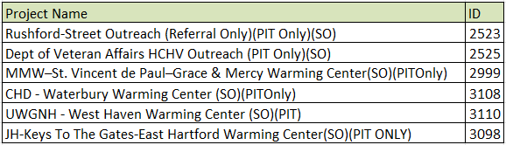

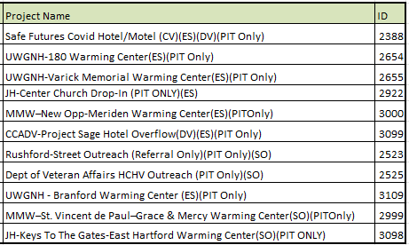

2). Hotels
Individuals/Families using a CAN Hotel Block Managed by CAN staff
Since hoteling has been extended and will be operational on the night of the PIT in most CANs, we need to capture as many people utilizing hotels in the existing HMIS hotel/motel programs.

Last year, most of your regions had an HMIS hotel/motel program enrollment. Please continue to use these HMIS enrollments for anyone entering a hotel block maintained by the CAN.

Please reach out to Nutmeg if a hotel enrollment is “inactive,” and the hotel enrollment can be used again. If you need a list of HMIS hotel programs in your region, please reach out. If needed, a new HMIS enrollment can be created.

For anyone in a hotel/motel HMIS program enrollment on the night of the PIT, the following workflow in HMIS will need to be completed – see link to guide:

HMIS Hotel.Motel PIT Count Process

The goal is to ensure that as many clients using hotels are enrolled in HMIS programs so that additional data entry and data cleanup is needed.

3). Individuals/Families only appearing on the Smartsheet:
In addition, we know that there may be instances (particularly if Governor’s Cold Weather activation is declared on the night of PIT) when an individual or family is hoteled by the CAN through the Smartsheet.

These households will not have a literally homeless project enrollment in HMIS for a variety of reasons. A process was initiated last year in which CAN wide projects were created in the PIT Database to capture individuals only appearing on the Hotel Smartsheet.

After data cleaning, demographic data was then entered by each of you or your staff.
Please confirm that you will be the user responsible for entering data for these individuals.

PIT App Program Name | ID
DOH-Central CAN-Hotel/Motel(ES)(PITOnly) | 2531
DOH-Hartford CAN-Hotel/Motel(ES)(PITOnly) | 2532
DOH-MMW CAN-Hotel/Motel(ES)(PITOnly) | 2536

4). CAN SmartSheets - Unsheltered Households:
As a final stopgap, for any records of unsheltered households on the night of the PIT count who are on the CAN Smartsheets, there are two options.

Option 1: The CAN will share the smartsheet with Nutmeg, Nutmeg will de-dup and send back to the CAN. At that point the CAN will manually enter the data into their corresponding PIT program in the PIT database. The programs are listed below.

Project Name | ID
BOS-Eastern CAN-Outreach-(PITOnly)(SO) | 2967
BOS-Central CAN-Outreach-(PITOnly)(SO) | 2968
BOS-Greater Hartford CAN-Outreach-(PITOnly)(SO) | 2969
BOS-Greater New Haven CAN-Outreach-(PITOnly)(SO) | 2970
BOS-MMW CAN-Outreach-(PITOnly)(SO) | 2971

Option 2: For any household on the CAN smartsheet, the CAN has the option of using the head of household Coordinated Access enrollment in HMIS. The CAN staff simply need to create a Current Living Situation Assessment using the CAN enrollment. The CLA only needs to be created for those households who are determined to be literally homeless on the night of the PIT count. Once the CLA is created the data will auto populate in the PIT database

PIT CLA guide: PIT CLA Guide for CAN and Outreach

Project Name | ID
Central CT Coordinated Access Network | 872
Fairfield County Coordinated Access Network | 945
Greater Hartford Coordinated Access Network | 955
Meriden-Middlesex County-Wallingford Coordinated Access Network | 960
Northwest Coordinated Access Network | 970
Greater New Haven Coordinated Access Network | 982
Eastern Coordinated Access Network | 1851

